Kevin Chung

10/7/19-10/11/19

Period 5

Journal 6

This week I successfully implemented the board detection method I detailed in my last journal entry. It takes the lines that are detected, and calls all the intersections between these points the “lattice points”. It then looks at every combination of four lines and evaluates them as possible boundaries. It does this by calculating where the lattice points should be based on those four lines and it then sees if they match up well with the aforementioned intersections. Last week, my implementation didn’t work because there were clumps of points around some of the intersections and all of them got counted as “matches”. I prevented this by adding the restriction that each intersection could only be matched with one point.

Additionally, I made a script to create a composite image of all the detected squares on the board and also create the corresponding image that has all the detected lines. They show how successful the board detection algorithm was. It correctly detected boards in 5/7 images, but on one of the images it labeled an outside boundary of the board as a board edge and in the other image it was very far off, most likely due to the fact that the edges in the image are not straight lines.

Successful image:

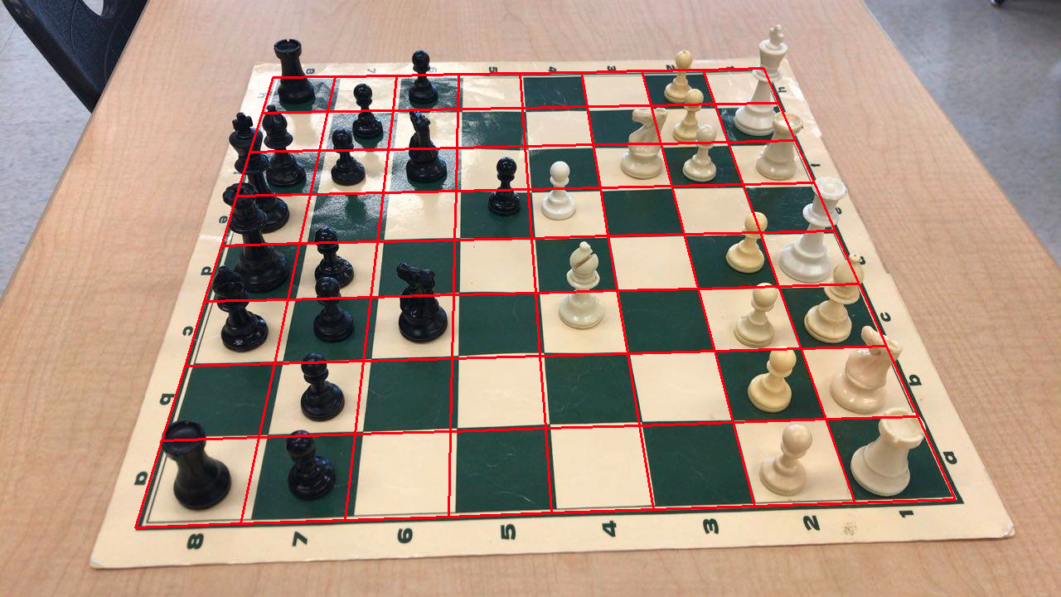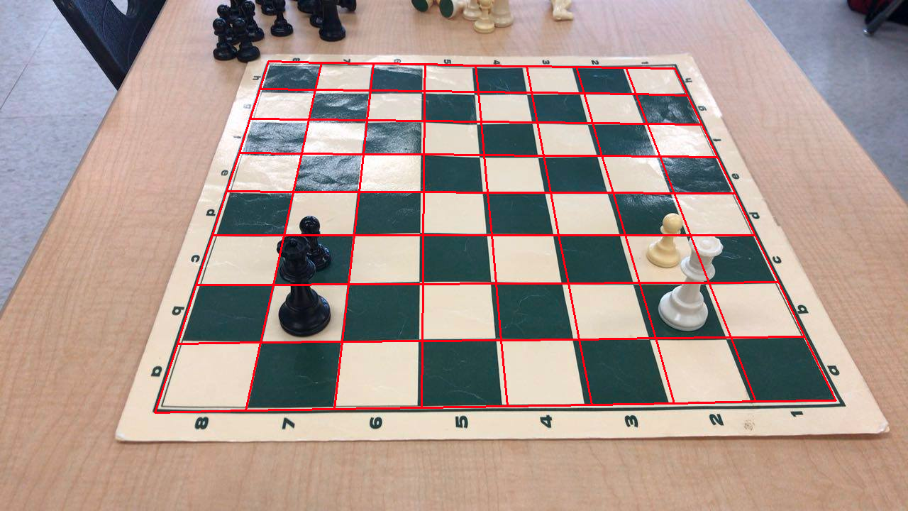

Unsuccessful images:

